Title of the Paper

Abstract
The abstract text should consist of 150 to 300 words. The abstract should contain: the purpose of the studies, background, methods used, main results, and conclusions of the work. At the end of the abstract, a few keywords should be specified to facilitate the searching for this paper in publication databases in the future. The information provided in the abstract must also be provided in the main body of the paper. No reference to tables and figures and no citations from literature should be included in the abstract. Any general or commonly known statements should not be allowed, either.
Keywords: keyword 1; keyword 2; keyword 3 (there should from 5 to 7 technical keywords or phrases, after each keywords should be a semicolon)
- Introduction
The titles of the main sections should be numbered with Arabic numerals, centred, and formatted in the Times New Roman font, size 12, bold, following the example shown. The text should be arranged in thematic sections. Individual sections should cover at least: introduction, research methods, results of tests and analyses, interpretation of the results, nomenclature or conclusions, and list of literature references.
The Introduction section serves as an introduction to the thematic scope of the article. It is necessary to explain why the specific topic is important and how it fits into the general context of the research field. Authors should identify knowledge gaps and clarify why their study is significant in the context of previously published works.
The introduction should include an extensive literature review (the most recent literature items presented in the largest databases). More than 50% of all the publications cited should be provided for in the Scopus database and the Web of Science database. The reference marks placed in the text to identify individual literature items should have the form of numerals put in square brackets: [23] or [1, 3, 10] or [1-3]. The simultaneous citing of more than 3 literature items should be avoided.
In the Introduction, it is crucial to clearly present the aim of the study, formulate specific hypotheses or research questions, and indicate what the authors are trying to achieve. The Introduction should also outline the structure of the paper and provide a brief description of the successive chapters.
A numerical value and its corresponding unit of measurement should be written with a space between (e.g. 32 km/h). Exception includes degrees (e.g., 42°C, 56°) and percentages (e.g., 16%). In case of range of numbers, we strongly recommend that the word “to” be used to indicate a range of values instead of a range dash. Examples: 0°C to 100°C or (0 to 100)°C or 0 km to 5 km or (0 to 5) km. When listing multiple values, it is necessary to repeat the unit each time (e.g., the study was conducted for speeds of 5 km/h, 10 km/h, 15 km/h, and 20 km/h).
- Materials and Methods
The Materials and Methods section should encompass detailed information regarding the research plan, procedures, tools, and techniques employed for data collection and analysis. Accuracy, clarity, and transparency of information are crucial in this section as they enable readers to comprehend how the study was conducted and why the methods chosen by the authors are suitable for their research objectives.
  - Subsection
The text should be cohesive and concern the issues raised in it. The bulleted list should look like this:
- first bullet,
- second bullet,
- third bullet.
The phenomena and issues dealt with in a subsection should be precisely presented and described.
Mathematic equations should be exclusively written in an equation editor, placed in separate lines, and numbered with Arabic numerals in round brackets. Every equation should be referred to in the main body and provided with a precise description of its individual elements. There should be a 6-pt space before and after any equation.
This is an example of an equation:
$E=\frac{1}{2}mV^{2}$ (1)
m – mass of a solid, kg
V – velocity of the solid, m/s.

- Results
The Results section should provide detailed information regarding the obtained outcomes. The most significant research findings should be presented clearly through tables, graphs, or other appropriate visualization tools. The content should be presented in a clear and logical manner, enabling the reader to understand and interpret the gathered data.
Any figures should be placed in the text and submitted as separate files in raster formats (such as JPEG, GIF, TIFF, etc.) with a resolution of (at least) 300 dpi. The figures must be numbered. No figures made in the WORD format and anchored in the text should be allowed.

Fig. 1. Title of the figure
All the figures provided should be referred to in the main body and denoted as Figure 1 (etc.). The title of a figure should be placed under the figure, centred, without a full stop at the end.
(a) | (b)
Fig. 2. Title of the figure; (a) text, (b) text, text text text text text text text text text text text text text text text text
Graphs and photographs should be treated as figures. They must be prepared in a graphic non-editable form. The photograph size must be at least 1 MB. Graphs must contain complete and unequivocal axis descriptions, inclusive of the SI units of measure. The symbols of the units should be put after a comma (see the example in Figure 3). The font used in the axis descriptions should be Times New Roman, size 11. Graphs with multiple data series should have a legend (Times New Roman, size 10). In black and white graphs, different line types should be used to enable identification.
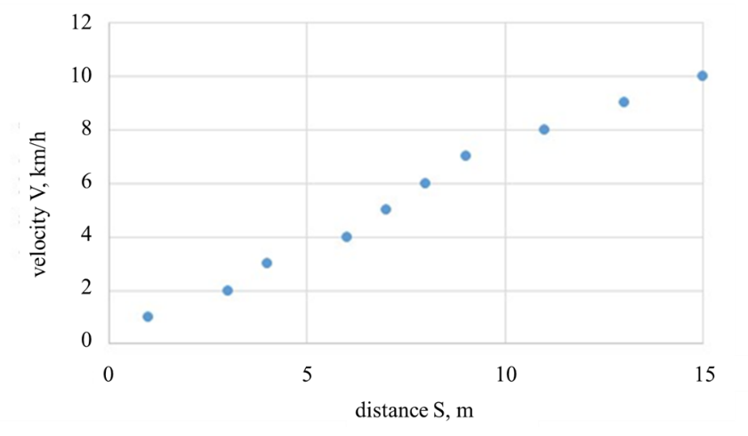
Fig. 3. Velocity as a function of distance
Tables in the paper should be numbered and referred to in the main body. All the tables should be denoted as Table 1 (etc.). Every table should be preceded by a title, without a full stop at the end. The data in the table should be provided with the same precision..
Tab. 1. Title of the table
Title 1 | Title 2 | Title 3
entry 1 | data | data
entry 2 | data | data
entry 3 | data | data

- Discussion
The Discussion section should include an analysis of the results in the context of the study's objectives, formulated hypotheses or research questions, in comparison to results obtained by other researchers. It should also address any potential methodological limitations and draw conclusions from the study. The Discussion should be written concisely, taking into account both theoretical and practical aspects of the research findings. The aim of this section is to enable the reader to understand the deeper context and interpretation of the obtained results.

- Conclusions
The recapitulation should contain the most important conclusions that have arisen from the considerations presented in the paper. It should not include statements that are commonly known. It should be cohesive with the paper content and should exclusively concern the work reported. In the Conclusions section, it is important to include information about whether the study achieved its objectives and provide answers to the research questions posed in the "Introduction" section. Additionally, you can discuss the significance of the obtained results for the research field and suggest directions for further studies. This section serves as a summary of the key findings and their implications, offering closure to the research presented in the paper.
- Acknowledgement
The paper submitted for the first time for publication in our periodical will be treated as an original. After the peer reviews are received, all changes to the paper should only be made in the “Track changes” mode.
- Nomenclature
CO carbon monoxide
EN European Norm International
- References
The reference items are ordered sequentially, numbered in square brackets. All of them must have reference marks in the text. In the case of articles with more than six authors, it is customary to list the first six authors and then use "et al.". Maximum one self-citation per 20 literature items in the reference list will be acceptable. The description of each item shall include the Digital Object Identifier (DOI), if assigned. The references should be prepared according to the Vancouver style:
Book: Author(s). Title. Edition. Place of publication: Publisher; Year.
Book chapter: Author(s). Title. Edition. Place of publication: Publisher; Year.
Journal article: Author(s). Article title. Journal Name. Year;Volume;(Issue):page range. URL DOI.
Conference Paper: Author(s). Article title. In: Conference, Conference Year Month Day(s); Conference place.
Website: Author(s). Title. Year. Available from: URL (cited Date).
Thesis: Author. Thesis title (type of thesis). Place of publication: Publisher; Year.

Reference list: Number the references in the list in the order they appear in the text.
- Wilkinson IB, Raine T, Wiles K, Goodhart A, Hall C, O’Neill H. Oxford handbook of clinical medicine. 10th ed. Oxford: Oxford University Press; 2017.
- Darden L. Mechanisms and models. In: Hull DL, Ruse M, editors. The Cambridge companion to the philosophy of biology. Cambridge: Cambridge University Press; 2008.
- Bute M. A backstage sociologist: Autoethnography and a populist vision. The American Sociologist. 2016;47(4):499–515. https://doi.org/10.1007/s12108-016-9307-z.
- Passey M, Gale J, Stirling J, Sanson-Fisher R. Caring for pregnant Aboriginal women: provider views on managing tobacco, alcohol and cannabis use. In: 2017 Primary Health Care Research Conference, 2017 Aug 7-9; Brisbane.
- Australian medicines handbook online. Adelaide (AU): Australian Medicines Handbook Pty Ltd; 2000. Paracetamol. Available from: https://amhonline-amh-net-au/ (accessed on 2023 Nov 10).
- Evans PR. Motor and sensory function of the upper digestive tract in health and in irritable bowel syndrome (Ph.D Thesis). Sydney, NSW: University of Sydney; 1998.

